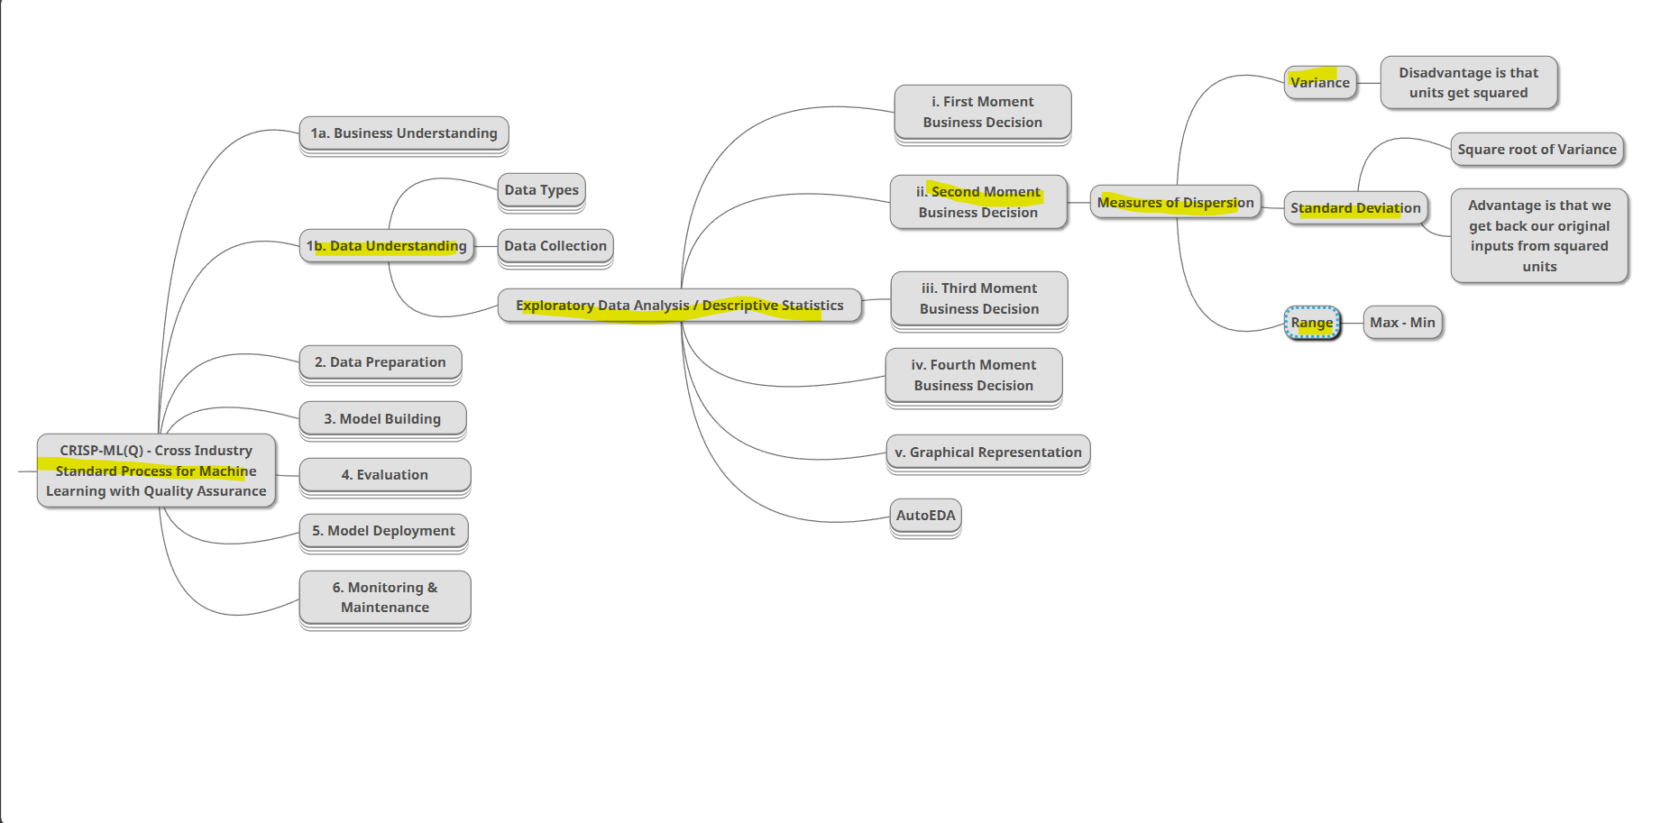

**SECOND MOVEMENT BUSINESS DECISIONS**

After finding the average on central tendency, measures of dispersion is calculated.

When a data point is goes up or down from the average that is called dispersion, so dispersion represents how data points are varied from it’s average, it is also called variance, in below consider the middle line is the average value and the other up and down lines are the dispersion of this data.

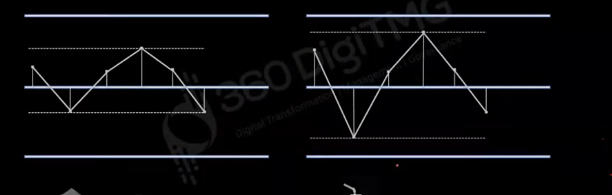

In standard deviation we find square root of variance.

**FORMULA**

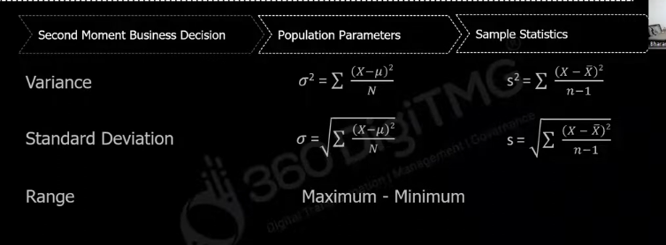

**Example for variance**

In this example X- mu is the variance of each weights from average.

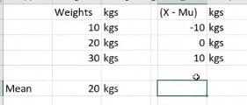

By seeing the each x-mu results we can say that data has variance, but when we sum all the X-Mu values it gives 0 that represents no variance is there,

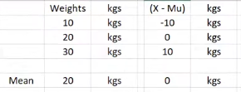

this is not right, So to find correct variance we have square each variance and sum them divide them

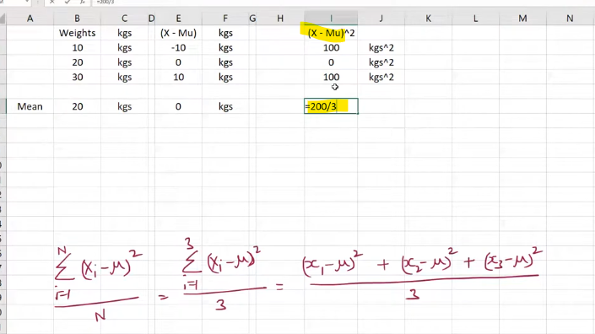

now below is the correct variance, what is kgs**2, that is the disadvantage of variance, units of the measures also gets squared. This can be solved with standard deviations.

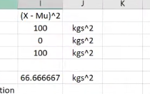

In standard deviation we uses find square root of variance, so sqr and sqr in units gets canceled

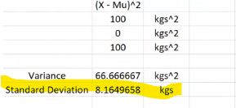

**Range –** Maximum value of variance – minimum value of variance

**IMPORTANT INTERVIEW QUESTION**

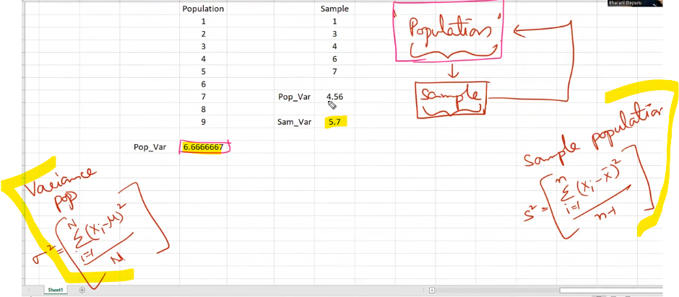

Why we have n-1 as sample population delimiter, Got find the closest population value is the reason, in above 4.56 is the sample population calculated with n as delimiter which is not closest to population value(6.6666667), 5.7 is the original sample population value that is calculated with n-1 delimiter